1. **Overview of the project:**

The purpose of this analysis is to know how different campaigns fared in relation to their launch dates and their funding goals to help Louise analyze her understanding of position of her play *Fever.*

I have used the Kickstarter dataset and filtered the campaign outcomes based on their launch dates and their funding goals for only plays under the subcategory. All plays with more than 85% of having met funding goals were selected since Fever has 86% funded status.

1. **Attached analysis – please see tab:**

Theater Outcomes by Launch Dt-C



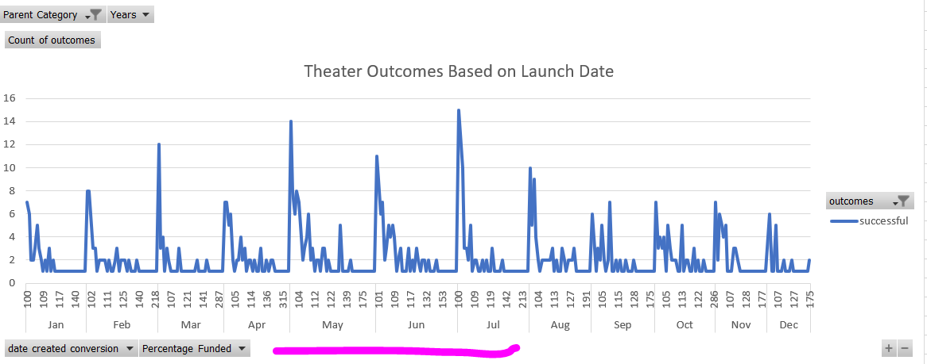

1. **Results:**

From Exercise 1, it is evident that plays those have been released during May, June & July of every year had greater success rate: 61% than a 36% failure rate.

1. **Challenges to build the data:**

Ranges had to be created for the goals and formulas written for each of the outcomes.



